**Assignment – 1**

**­­­­TITLE:** Retail store stock inventory analytics

**Roll no:** 718019L244

**Dataset:** 50_startup

1.ADMINISTRATION BY STATE:

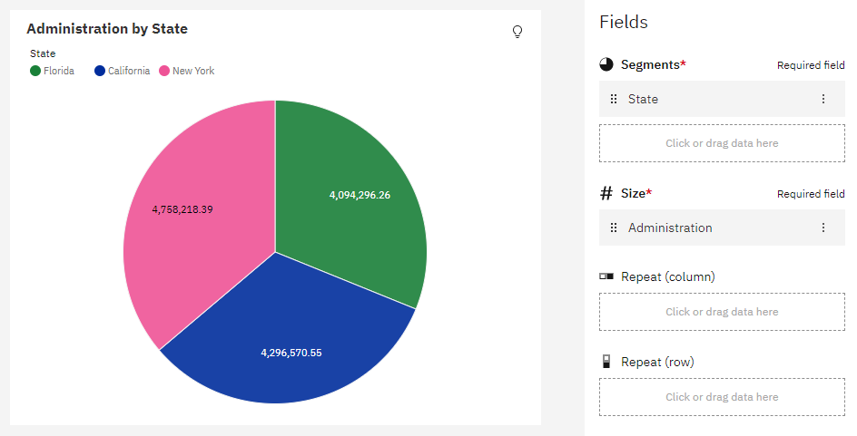

2.R&D ADMINISTRATION AND MARKETING IN PIE CHART:

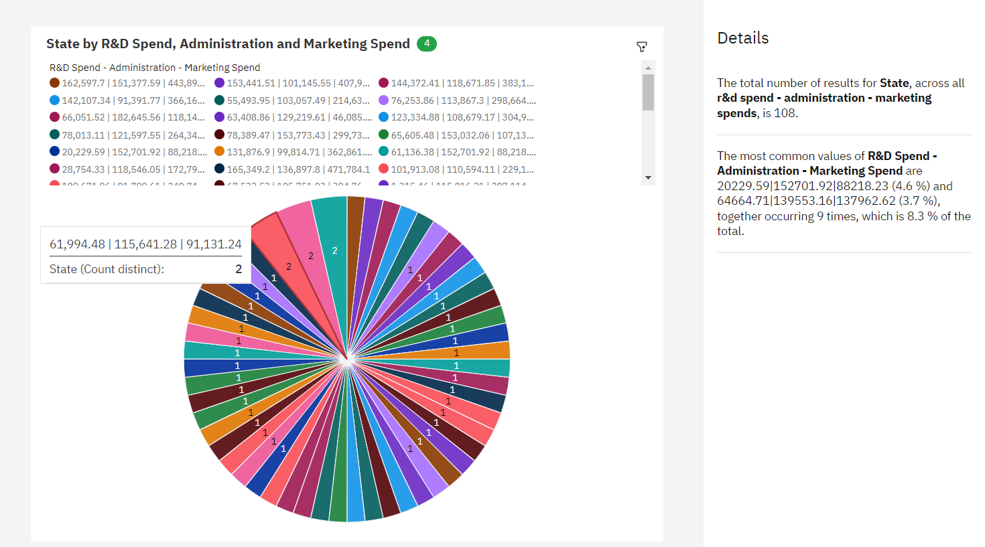

3. MARKETING SPENDS VS R&D IN BAR GRAPH AND HIERARCHY CIRCLE:

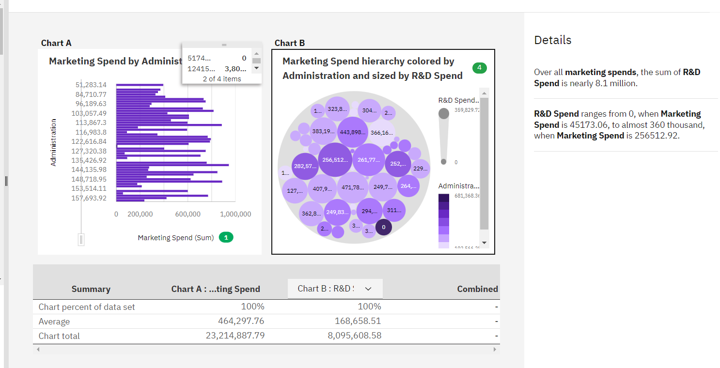

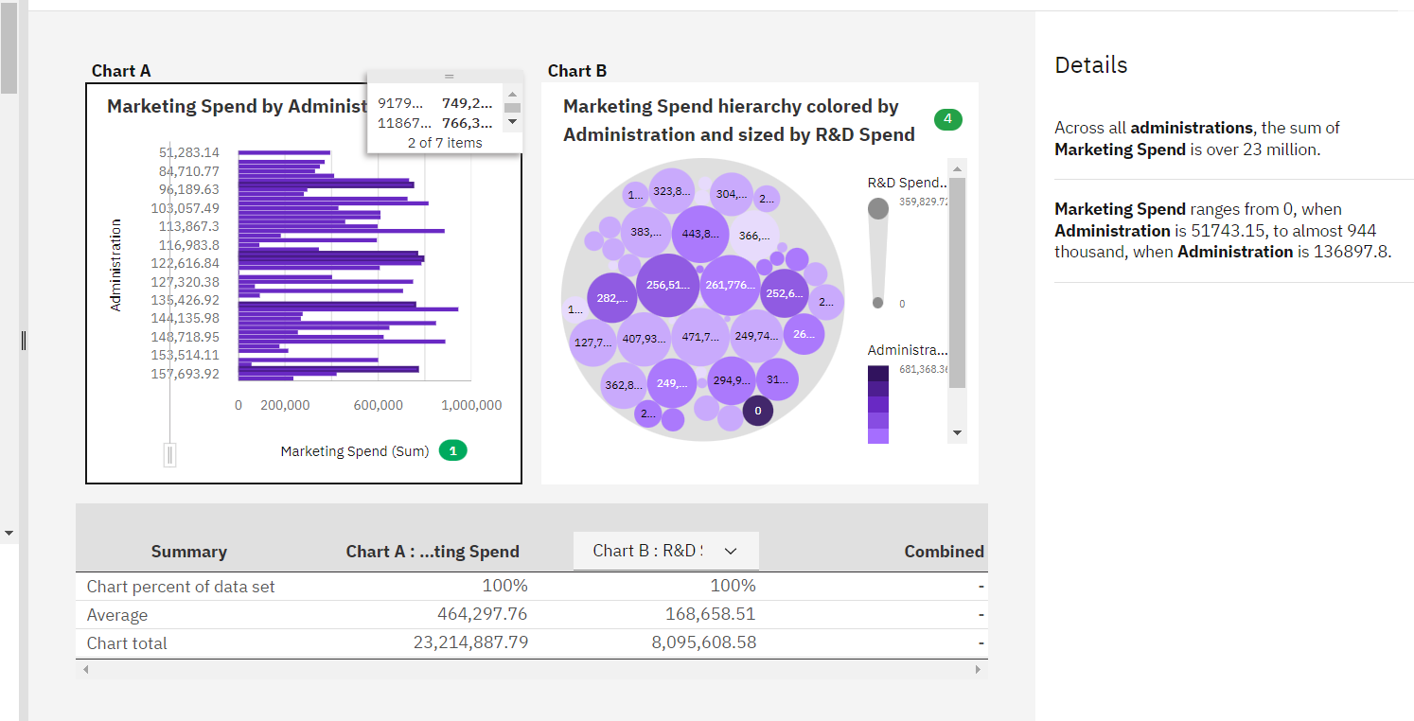

4. R&D SPEND & PROFIT BY STATE:

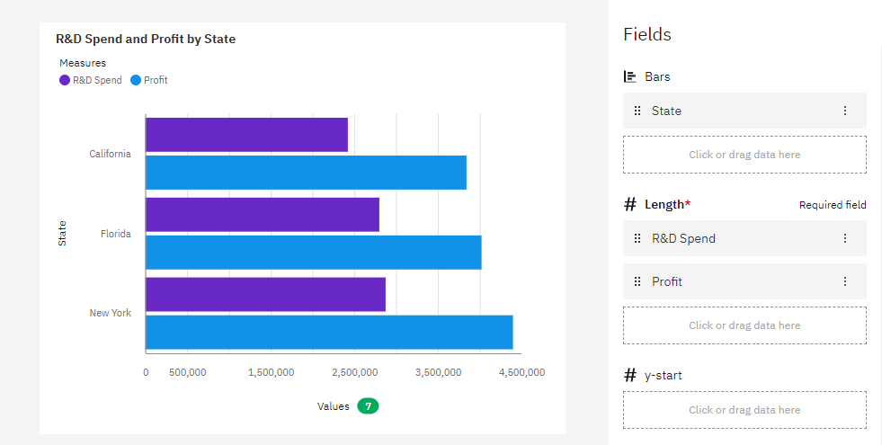

5. ADMINISTRATION & MARKETING SPEND BY STATE:

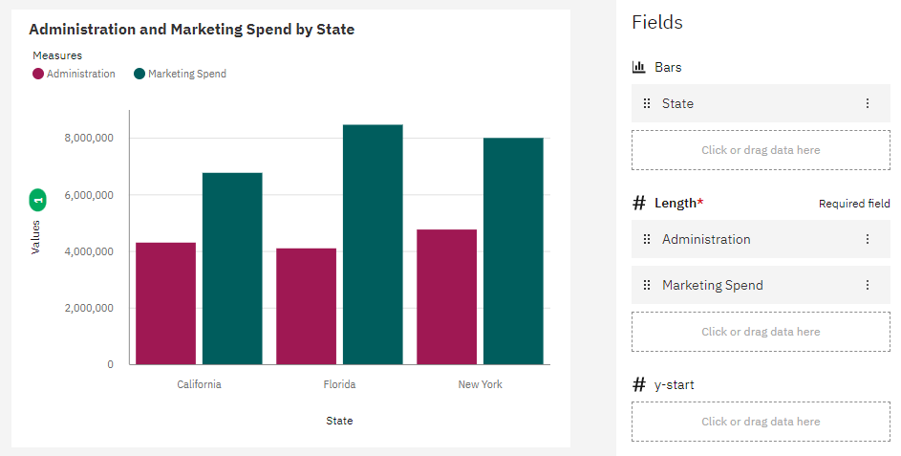

6. COMPARISON ON PROFIT BY R&D SPEND AND BY MARKETING SPEND :

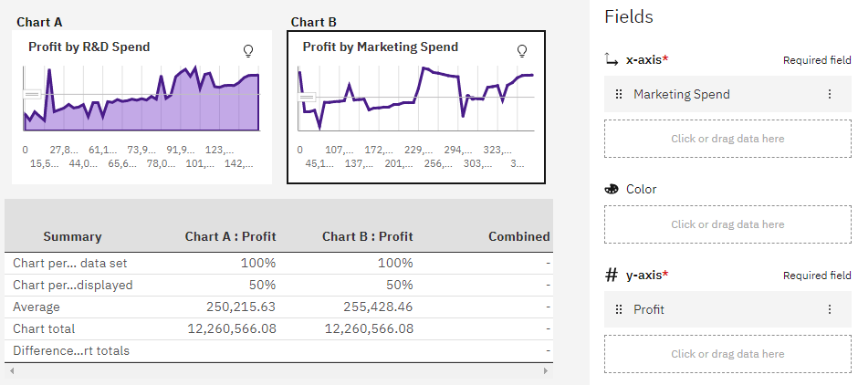

7.REGIONAL MAP OF SPENDING ANALYSIS:

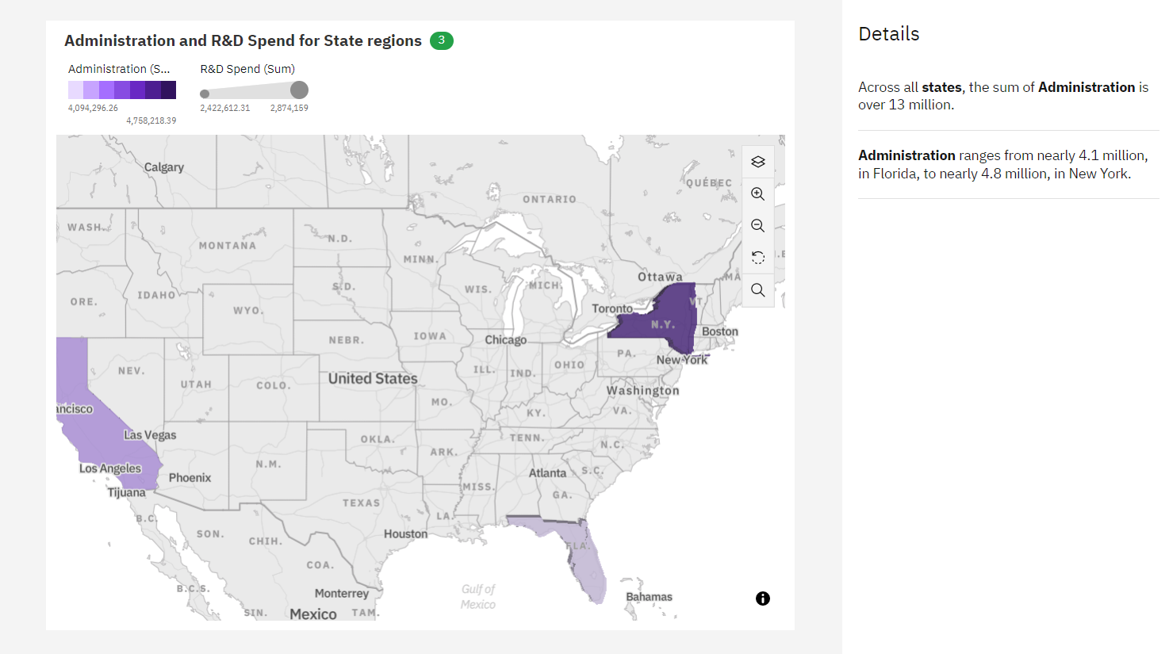

8. PROFIT BY COLOURED STATE:

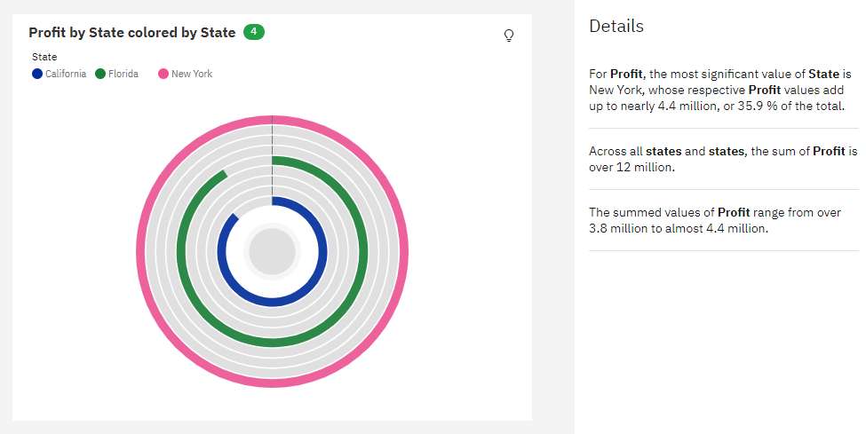

9. R&D IN SPIRAL:

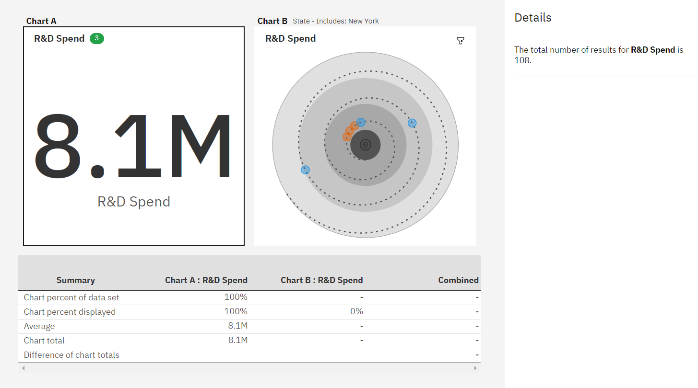

10. PROFIT VS R&D:

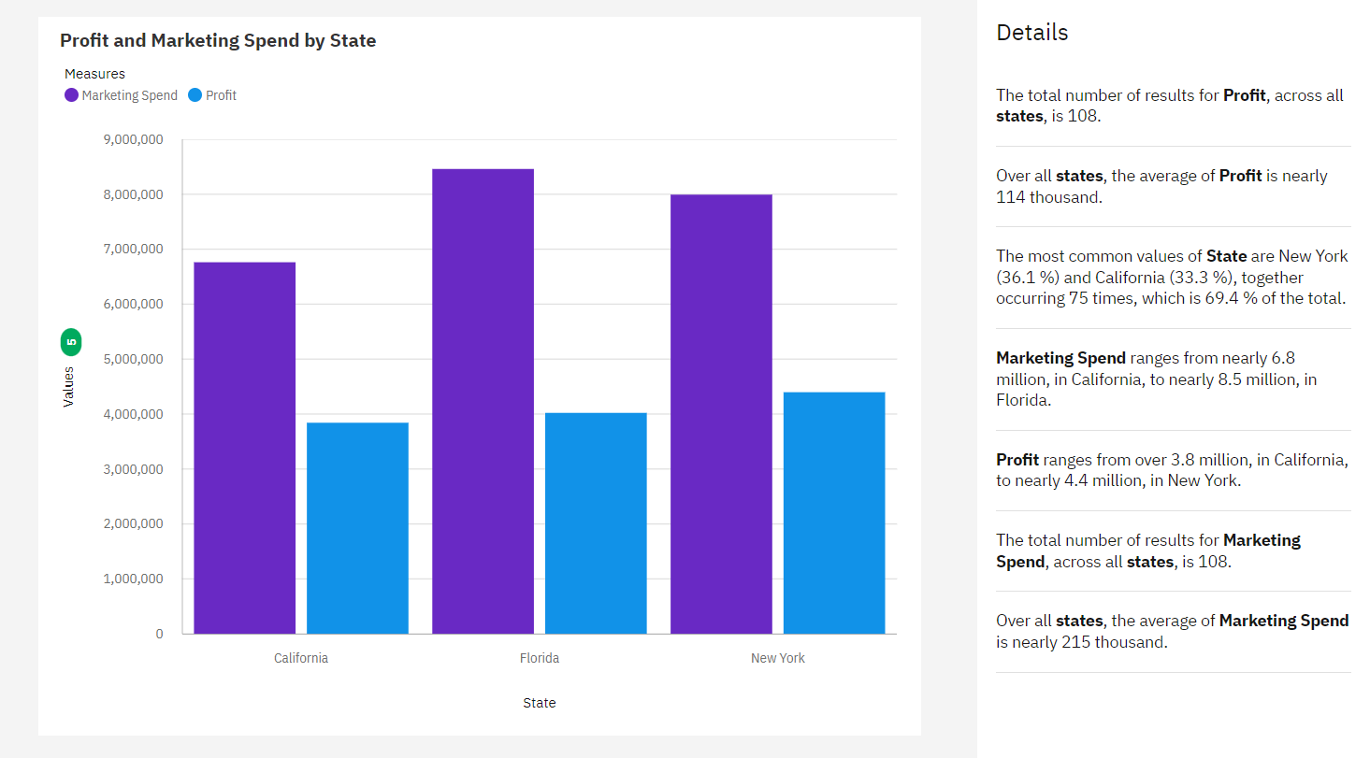

11. PROFIT VS MARKETING SPEND:

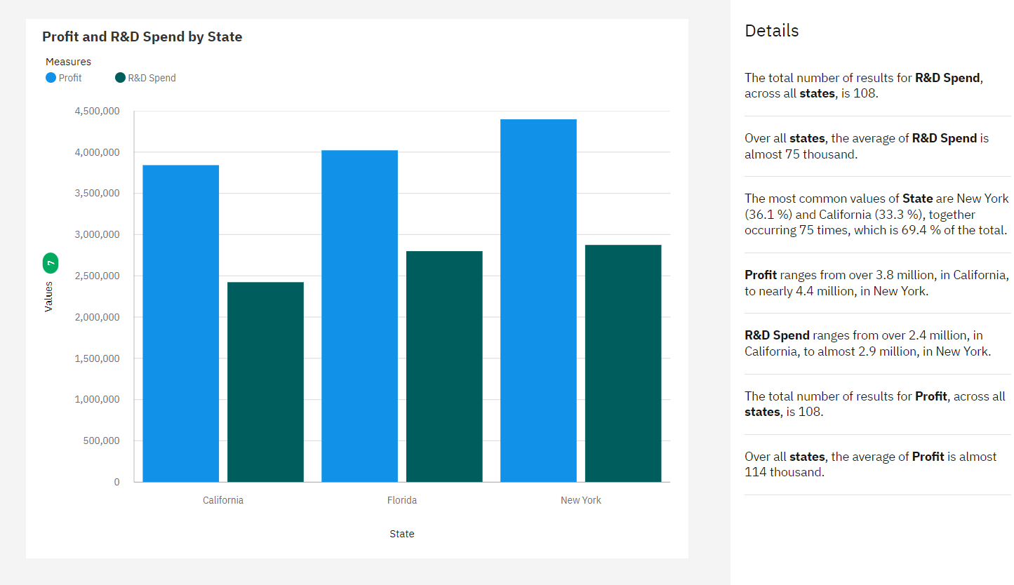

12. STATE COLOURED BY PROFIT SIZED AND ADMNISTRATION AND STATE SIZED BY PROFIT:

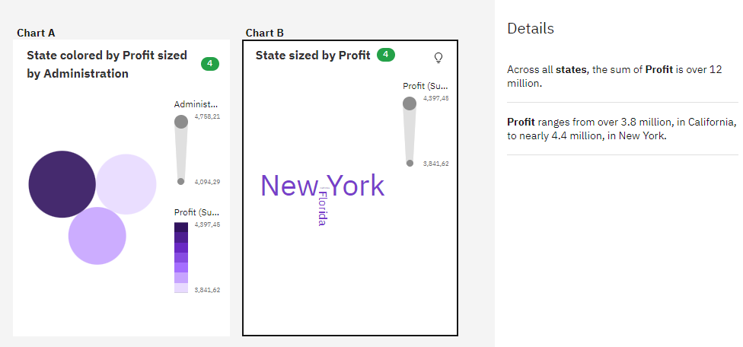

13. PROFIT BY R&D SPEND:

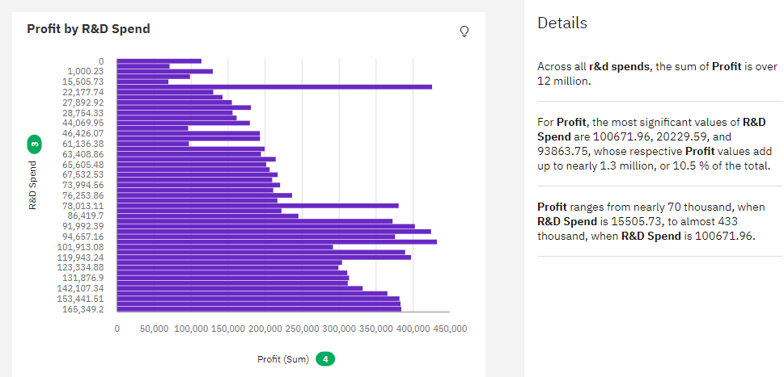

14. PROFIT ON STATE WISE AND WITH RESPECT TO R&D AND MARKETING:

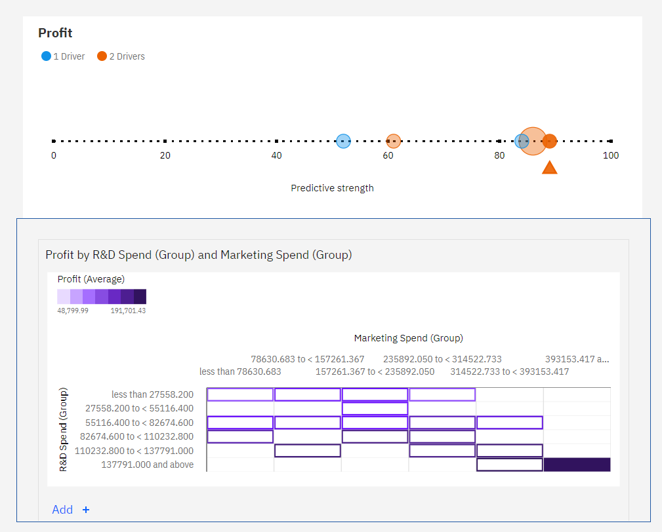

15. STATE BY R&D SPEND:

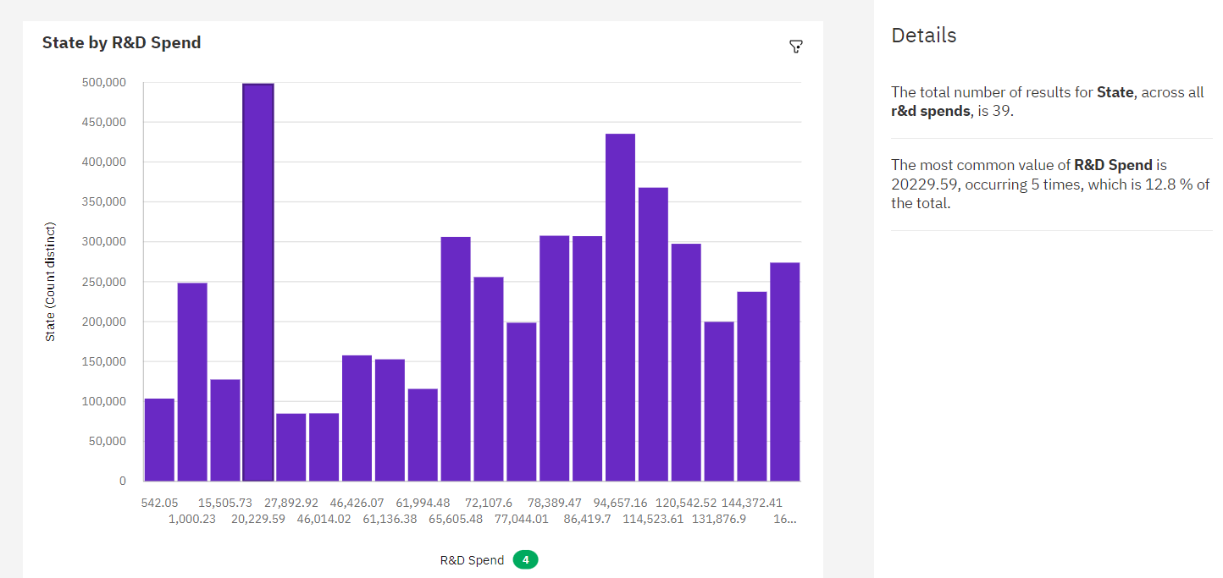

16. State and R&D Spend compared to Profit by R&D Spend and Marketing Spend:

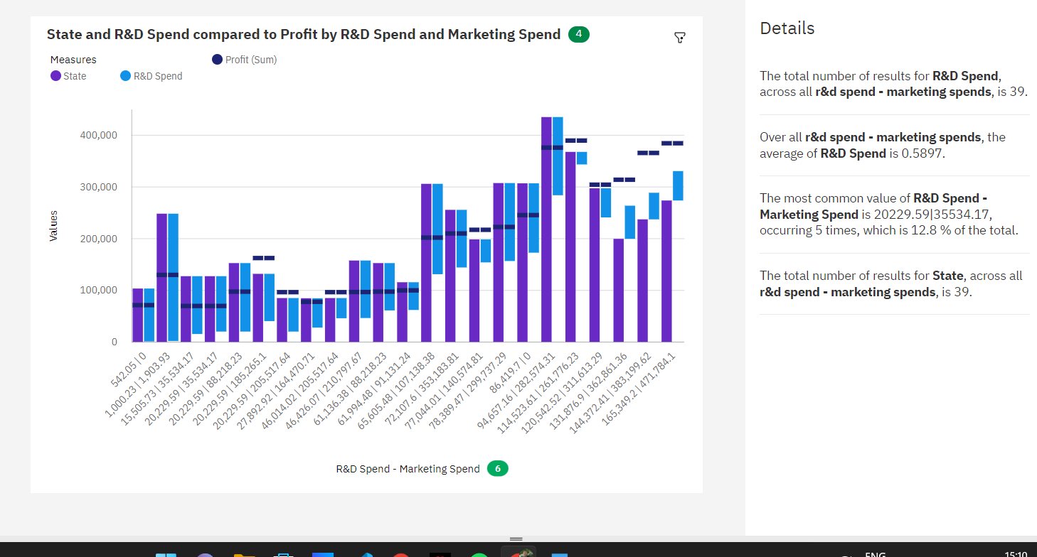

17. MARKETING SPEND COMPARED TO PROFIT BYY R&D SPEND, MARKETING SPEND AND PROFIT:

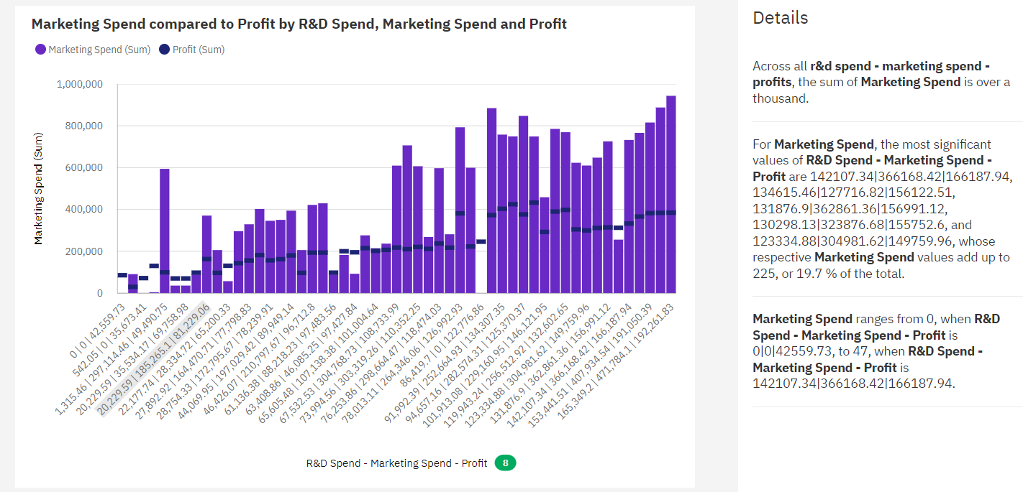

**LINK-** [**https://us3.ca.analytics.ibm.com/bi/?perspective=content&tab=myContent&folder=i44C92E2FA3DA4F6F93F04F16B39339E9**](https://us3.ca.analytics.ibm.com/bi/?perspective=content&tab=myContent&folder=i44C92E2FA3DA4F6F93F04F16B39339E9)